EMPLOYEES' PROVIDENT FUND ORGANISATION

Employees' Provident Funds Scheme, 1952 ( Paragraph 34 & 57) & Employees' Pension Scheme, 1995 (Paragraph 24)

# New Form No. - 11 - Declaration Form

*(To be retained by the employer for future reference)*

# (Declaration by a person taking up employment in any establishment on which EPF Scheme 1952 and/or EPS 1995 is applicable)

| 1 | Name of the member | Anushka Srivastava | | |
| --- | --- | --- | --- | --- |
| 2 | Father's Name Chandra Shekhar ✅ Spouse's Name |  | | |
| (Please tick whichever is applicable) |
| 3 | Date of Birth (DD/MM/YYYY) | 20/09/1999 | | |
| 4 | Gender : (Male/Female/Transgender) | Female | | |
| 5 | Marital Status (Married/Unmarried/Widow/Widower/Divorcee) | Unmarried | | |
| 6 | (a) Email ID: | [anushkasrivastavax@gmail.com](mailto:anushkasrivastavax@gmail.com)  6388647012 | | |
| (b) Mobile No.: |
| 7 | Whether earlier a member of Employees' Provident Funds Scheme 1952 **(Yes/No)** | No | | |
| 8 | Whether earlier a member of Employees' Pension Scheme, 1995 **(Yes/No)** | No | | |
| 9 | **Previous employment details: [if Yes to 7 AND/OR 8 above]** | Not applicable | | |
| a) Universal Account Number: |
| b) Previous PF Account Number: |  | | |
| c) Date of exit from previous employment (DD/MM/YYYY) |  | | |
| d) Scheme Certificate No. (if issued) |  | | |
| e) Pension Payment Order (PPO) No. (if issued) |  | | |
| 10 | a) International Worker **(Yes/No.)** | No | | |
| b) If yes, state country of origin (India/Name of other country) |  | | |
| c) Passport No. |  | | |
| d) Validity of Passport [(DD/MM/YYYY) to (DD/MM/YYYY) |  | to |  |
| 11 | **KYC Details**: (attach self attested copies of following KYCs) |  | | |
| a) Bank Account No. & IFS Code |  | | |
| b) Aadhaar Number | 820326299753 | | |
| c) Permanent Account Number (PAN), if available | OMSPS4072J | | |

**UNDERTAKING**

1. Certified that the particulars are true to the best of my knowledge.
2. I authorize EPFO to use my Aadhaar for verification/authentication/eKYC purpose for service delivery.
3. Kindly transfer the funds and service details, if applicable, from the previous PF account as declared above to the present P.F. Account.

(The transfer would be possible only if the identified KYC detail approved by previous employer has been verified by present employer using his Digital Signature Certificate)

1. In case of changes in above details, the same will be intimated to employer at the earliest.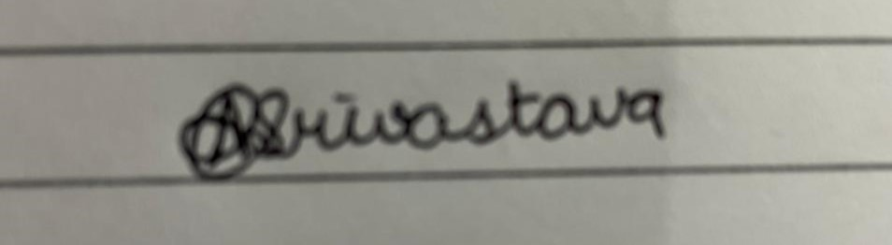

| Date:7-02-2022 |  |
| --- | --- |
| Place:Lucknow | **Signature of Member** |
| **DECLARATION BY PRESENT EMPLOYER** | |

| A. | The member Mr./Ms./Mrs. |  | has joined on |  | and has been allotted PF Number |
| --- | --- | --- | --- | --- | --- |
|  |  |  |  |  |  |
| B. | In case the person was earlier not a member of EPF Scheme, 1952 and EPS, 1995: | | |  |  |
|  | * **(Post allotment of UAN)** The | UAN allotted for the member is |  |  |  |
|  | **\* Please Tick the Appropriate** | **option:** |  |  |  |
|  | The KYC details of the above me | mber in the UAN database |  |  |  |
|  | () Have not been uploaded. |  |  |  |  |
|  | () Have been uploaded by not | approved |  |  |  |
|  | () Have been uploaded and appr | oved with DSC |  |  |  |
| C. | In case the person was earlier a member of EPF Scheme 1952 and EPS, 1995: | | |  |  |
|  | * The above PF Account number/UAN of the member as mentioned in (A) above has been tagged with his her UAN/Previous member ID as declared by member. | | | | |
|  | **\* Please Tick the Appropriate** | **Option** |  |  |  |
|  | () The KYC details of the above member in the UAN database have been approved with Digital Signature Certificate and transfer request has been generated on portal. | | | | |
|  | () As the DSC of establishment are not registered with EPFO, the member has been informed to file physical claim (Form 13) for transfer of funds from his previous establishment. | | | | |

| Date: | **Signature of Employer with Seal of Establishment** |
| --- | --- |